

**ldowu Ejere ..,. ONLY IN NIGERIA**



10 hours ago • IE

•••

Introducing the Authemanshop marketplace at www.authemanshop.com where you can buy and sell your fashion,consumables, electronics and household goods. This is ideal for those who want to sell online but cannot afford a website or online marketing.

A uthemanshop offers low commission rates and strategic marketing that gives you access to a wider market across Nigeria. Simply click on the link to go to the marketplace.Contact **Ajiga Olugbenga Felix** for more info.

Get your business featured on OIN premium ads by contacting any of our admins today and start selling to the right crowd of over 30k OINers from across Nigeria. Remember a business without ads is like winking in the dark...

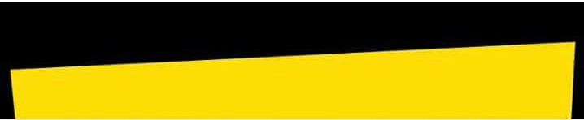

Coj Write a comment...

